**Competitive Coding Lab 1**

**Student Name: Sahul Kr. Parida UID: 20BCS4919**

**Branch: CSE Section/Group: WM-904/B**

**Semester: 5th Date of Performance: 04/08/22**

**Subject Name: Competitive Coding(CC) Subject Code: 20CSP-314**

**PROBLEM STATEMENT 1: -**

[**https://www.hackerrank.com/challenges/30-arrays/problem**](https://www.hackerrank.com/challenges/30-arrays/problem)

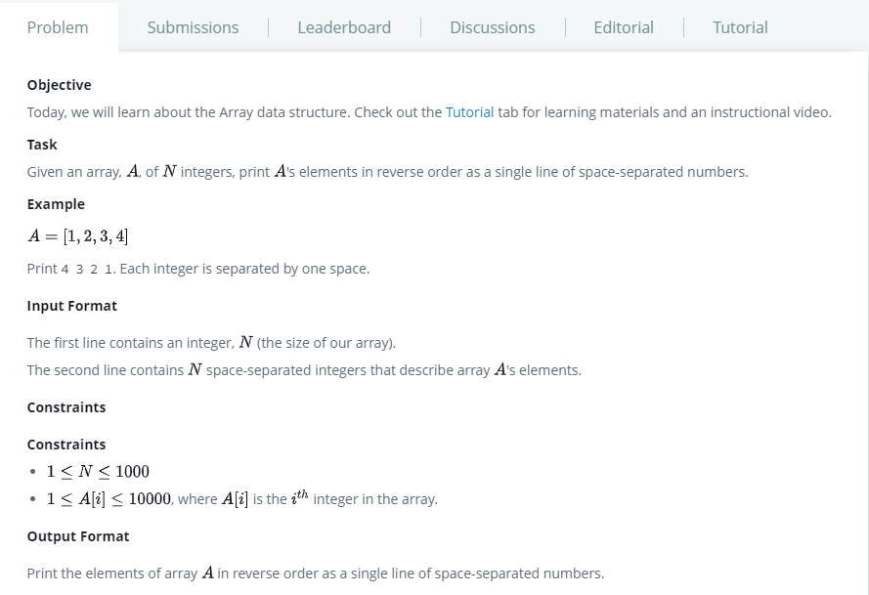

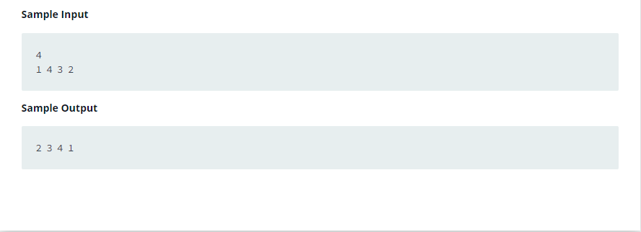

**SOLUTION:**

import java.util.*;

/* 20BCS4919_Sahul Kumar Parida */

public class Solution {

    public static void main(String[] args) {

        Scanner sc = new Scanner(System.in);

        int n = sc.nextInt();

        int[] arr = new int[n];

        //Array initialization

        for(int i=0; i < n; i++){

            arr[i] = sc.nextInt();

        }

        sc.close();

        //Reversing the array

        for(int i = n - 1; i > -1; i--){

            System.out.print(arr[i] + " ");

        }

    }

}

# TEST CASES:

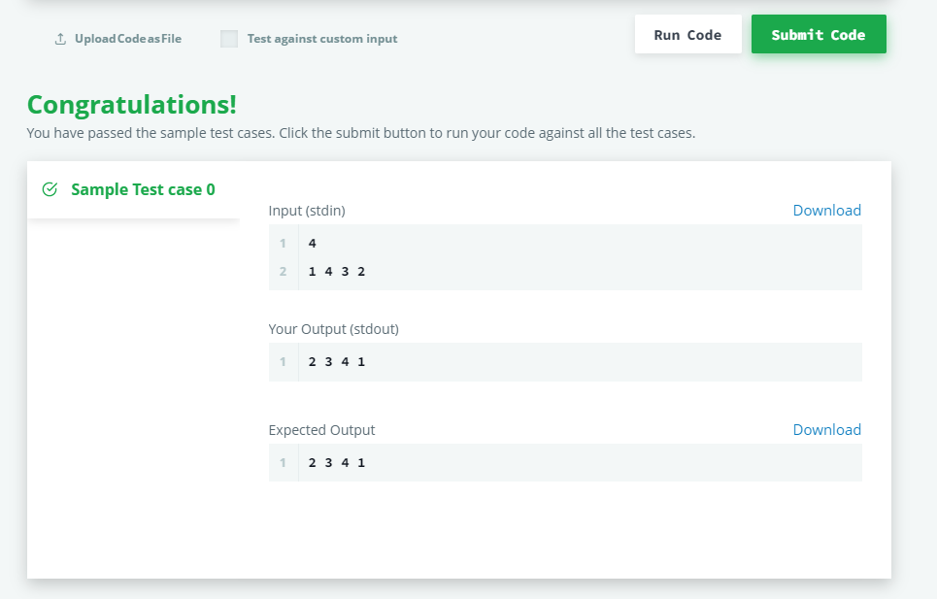

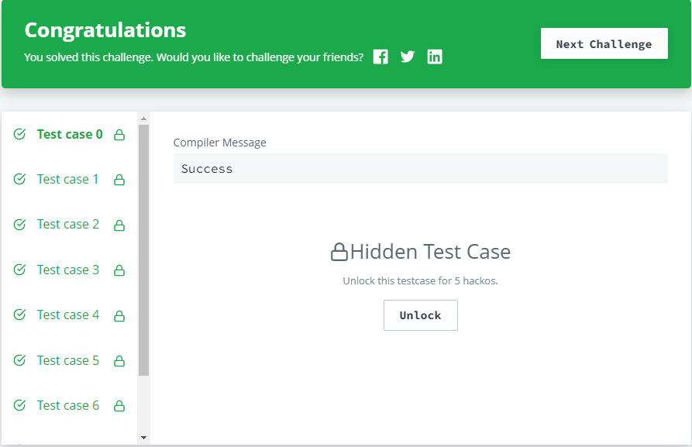

**PROBLEM STATEMENT 2: -**

[**https://www.hackerrank.com/challenges/simple-array-sum/problem**](https://www.hackerrank.com/challenges/simple-array-sum/problem)

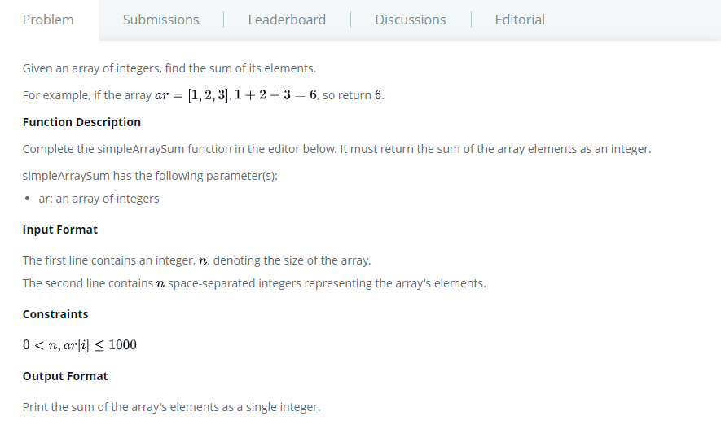

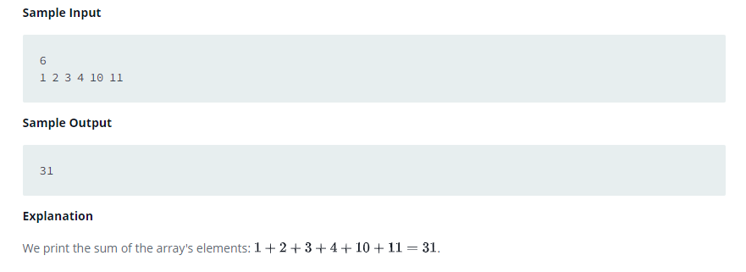

# SOLUTION:

import java.util.*;

/* 20BCS4919_Sahul Kumar Parida */

public class Solution {

    public static void main(String[] args) {

        Scanner sc = new Scanner(System.in);

        int N =sc.nextInt();

        int[] sum = new int[N];

        int total =0;

        //sum of array elements

        for(int i=0;i<N;i++){

            sum[i] = sc.nextInt();

            total = total + sum[i];

        }

        System.out.println(total);

    }

}

# TEST CASES:

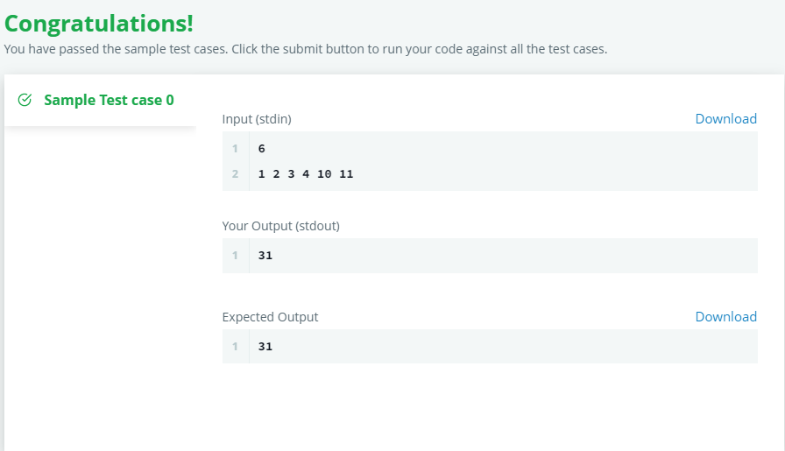

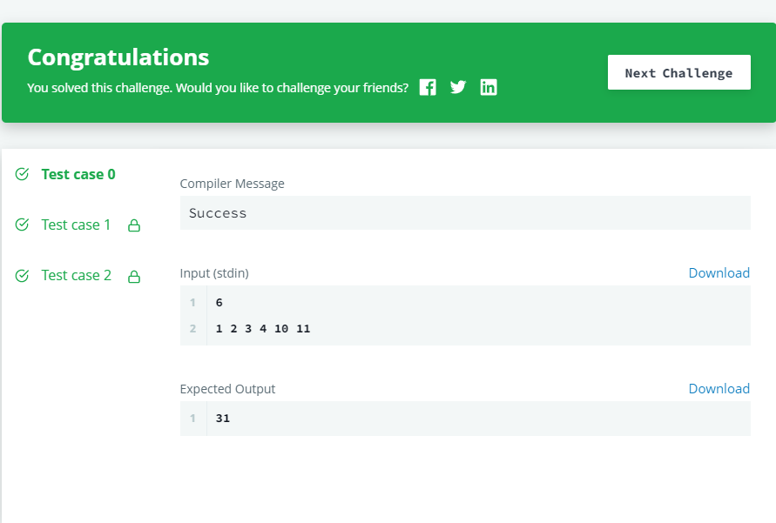

**Evaluation Grid (To be created as per the SOP and Assessment guidelines by the faculty):**

|  |  |  |  |
| --- | --- | --- | --- |
| Sr. No. | Parameters | Marks Obtained | Maximum Marks |
| 1. |  |  |  |
| 2. |  |  |  |
| 3. |  |  |  |
|  |  |  |  |